**Report on the effectiveness of employment programs**

1. **Summary of Respondents**
2. **Total Number of Respondents**: The total number of respondents who answered the survey is **1000**.
3. **Number of Respondents in Each Program Group**: The respondents are divided into three program groups:

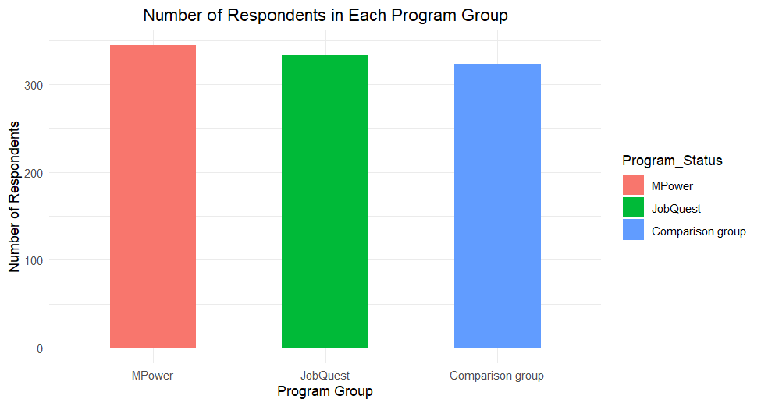

| **Program** | **Number of Respondents** |
| --- | --- |
| MPower | 344 |
| JobQuest | 333 |
| Comparison | 323 |

1. **Breakdown by Gender**: The gender distribution of the respondents is as follows:

| **Gender** | **Number of Respondents** |
| --- | --- |
| Male | 484 |
| Female | 516 |

1. **Breakdown by Indigenous Identity**: The Indigenous identity distribution among the respondents is:

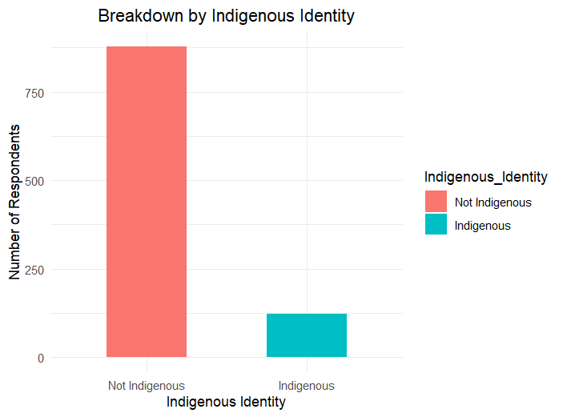

| **Indigenous Identity** | **Number of Respondents** |
| --- | --- |
| Not Indigenous | 878 |
| Indigenous | 122 |

1. **Breakdown by Immigration History**: The immigration history of the respondents is as follows:

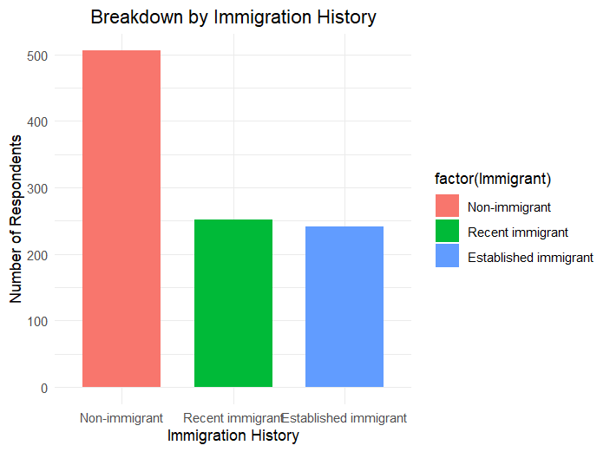

| **Immigration History** | **Number of Respondents** |
| --- | --- |
| Non-immigrant | 506 |
| Recent immigrant (within past 2 years) | 252 |
| Established immigrant (more than 2 years) | 242 |

1. **Effectiveness of Employment Programs in helping participants find work**

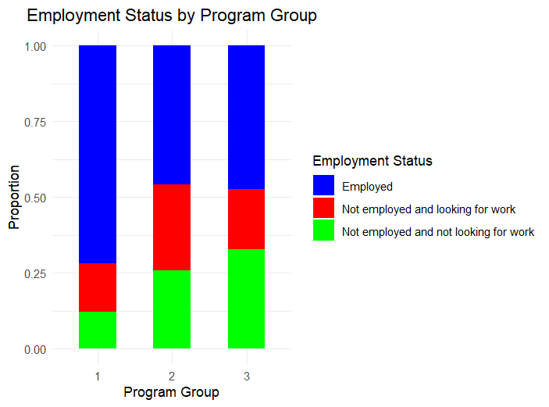

**Proportion Table with Percentages**

The proportion table shows the distribution of employment status within each program group in percentages.

| **Employment Status** | **MPower (%)**  **(Program Group 1)** | **JobQuest (%)**  **(Program Group 2)** | **Comparison (%)**  **(Program Group 3)** |
| --- | --- | --- | --- |
| Employed | 71.8 | 45.95 | 47.37 |
| Not employed and looking for work | 15.99 | 28.23 | 19.81 |
| Not employed and not looking for work | 12.21 | 25.83 | 32.82 |

**Chi-squared Test Results**

The Chi-squared test is used to determine if there is a significant association between program participation (MPower, JobQuest, Comparison group) and employment status.

**Interpretation:**

1. **X-squared (Chi-squared statistic)**: 69.769
   * This value represents the test statistic calculated from the observed and expected frequencies of the employment status across the program groups.
2. **Degrees of Freedom (df)**: 4
   * The degrees of freedom for the Chi-squared test is calculated as (number of rows - 1) * (number of columns - 1). Here, we have 3 employment statuses and 3 program groups, so df = (3-1) * (3-1) = 4.
3. **p-value**: 2.54e-14 (approximately 0.0000000000000254)
   * The p-value indicates the probability of observing the test statistic as extreme as the one computed, under the null hypothesis that there is no association between the variables.

**Significance:**

* **p-value < 0.05**: The p-value is much smaller than the typical significance level of 0.05, indicating strong evidence against the null hypothesis.
* **Conclusion**: There is a statistically significant association between program participation and employment status. This means that the distribution of employment status significantly differs among the MPower, Job Quest, and Comparison groups.

The Chi-squared test indicates a significant association between program participation and employment status. The MPower program shows the highest proportion of employed participants (71.8%) compared to JobQuest (45.95%) and the Comparison group (47.37%).

This suggests that the MPower program is more effective in helping participants find jobs compared to the JobQuest program and those who did not participate in any program.

1. **Impact of Program Completion on Hourly Wages**

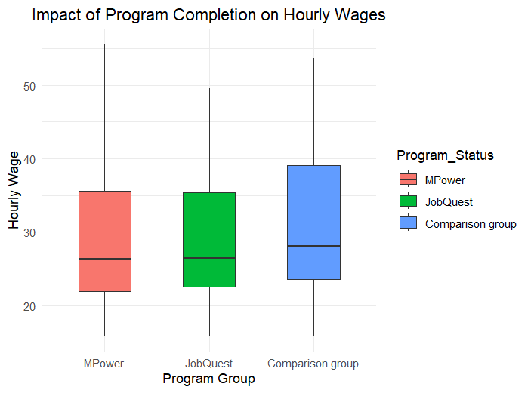

**Description of the Graph**

The graph presented is a boxplot that illustrates the distribution of hourly wages among employed participants in three different program groups: MPower, JobQuest, and a Comparison group. Each boxplot provides a summary of the wage data for each group, including the median, quartiles, and potential outliers.

**Key Points from the Graph**

**Median Hourly Wage:**

**MPower:** The median hourly wage for participants in the MPower program is approximately 30.

**JobQuest:** The median hourly wage for participants in the JobQuest program is also around 30.

**Comparison Group:** The median hourly wage for participants who did not complete any program is higher, around 35.

**Interquartile Range (IQR):**

**MPower:** The IQR, which represents the middle 50% of the data, spans from approximately 25 to 35.

**JobQuest:** The IQR for JobQuest is similar, spanning from around 25 to 35.

**Comparison Group:** The IQR for the Comparison group is wider, ranging from about 30 to 40.

**Range and Outliers:**

**MPower:** The wages range from about 20 to 40, with no significant outliers.

**JobQuest:** The wages also range from approximately 20 to 40, with no significant outliers.

**Comparison Group:** The wages range from around 25 to 50, indicating a broader spread in the data compared to the other two groups.

**Overall Distribution**

The Comparison group has a higher median wage and a broader distribution of wages compared to both the MPower and JobQuest groups. This suggests that participants who did not complete either program might be earning higher wages on average.

**Statistical Analysis**

Among survey participants who were employed at the time of the survey, the ANOVA test was used to compare the hourly wages across the three program groups: MPower, JobQuest, and the Comparison group.

**ANOVA Results**

The ANOVA results indicated no significant difference in hourly wages among the different program groups (F (2, 550) = 1.8, p = 0.166).

**Post-hoc Analysis (Tukey's HSD)**

| **Comparison** | **Difference in Mean Wages** | **95% CI Lower Bound** | **95% CI Upper Bound** | **p-value** |
| --- | --- | --- | --- | --- |
| Job Quest (2) - MPower (1) | -0.23 | -2.50 | 2.04 | 0.969 |
| Comparison (3) - MPower (1) | 1.59 | -0.68 | 3.87 | 0.227 |
| Comparison (3) - Job Quest (2) | 1.83 | -0.70 | 4.35 | 0.207 |

**Interpretation**

* **MPower vs. Comparison Group**: The difference in mean wages is not statistically significant (p = 0.227).
* **JobQuest vs. MPower**: The difference in mean wages is not statistically significant (p = 0.969).
* **JobQuest vs. Comparison Group**: The difference in mean wages is not statistically significant (p = 0.207).

Based on the ANOVA and Tukey's HSD post-hoc analysis, there is no evidence to suggest that the MPower or JobQuest programs significantly impact the hourly wages of employed participants compared to the comparison group.

**Final Conclusion:**

The MPower program appears to be effective in helping participants find employment, as evidenced by the higher proportion of employed participants compared to the JobQuest and Comparison groups. However, neither the MPower nor the JobQuest program significantly impacts the hourly wages of employed participants. This suggests that while these programs may improve employment outcomes, they do not necessarily lead to higher-paying jobs. Further investigation into other factors influencing wage levels and additional support for program participants may be necessary to enhance the overall effectiveness of these employment programs.